Question A
TwoScouts
Problem Description
Two elite scouts, Arin and Bran, are stationed in different towns. Their mission: each must deliver an encrypted message to the main outpost.
In the distant land of Graphonia, towns are connected by a network of roads. Communication between these towns is crucial for survival. The main outpost has become the hub for vital resources and intelligence.
Due to the sensitive nature of their information, the scouts must take separate routes to the outpost. They can only meet at the outpost—nowhere else. Each scout must travel along a path where:
- Each scout ensures that no town is visited more than once throughout their assignment.
- The two scouts' paths do not overlap at any town except the outpost.
The High Council wants to minimize the total number of towns visited by both scouts to ensure efficiency and reduce risk.
Your task: As the Royal Programmer, determine the minimum total number of towns visited by both scouts. If it is impossible for both scouts to reach the outpost under these constraints, report "Impossible".
Constraints
3 <= N <= 15
Input
The first line contains two space-separated integers:
N — the number of towns
M — the number of roads connecting them
The next M lines each contain two space-separated integers, a and b, indicating that town a and town b are connected by a road.
The following line contains two space-separated integers: the starting towns of the two scouts.
The last line contains the integer representing the outpost town.
Output
Output a single integer: the minimum number of towns visited by both scouts, or "Impossible" if such paths do not exist.
Time Limit (secs)
1
Examples
Example 1
input
14 16
1 2
2 3
3 4
4 5
5 6
6 7
1 8
8 9
9 10
10 7
1 11
11 12
11 13
13 14
14 7
10 11
1 12
7
Output
8
Explanation
From the first line it is seen that there are 14 towns and 16 roads connecting them.
Arin is in town 1 and Bran is in town 12 and the outpost at 7.
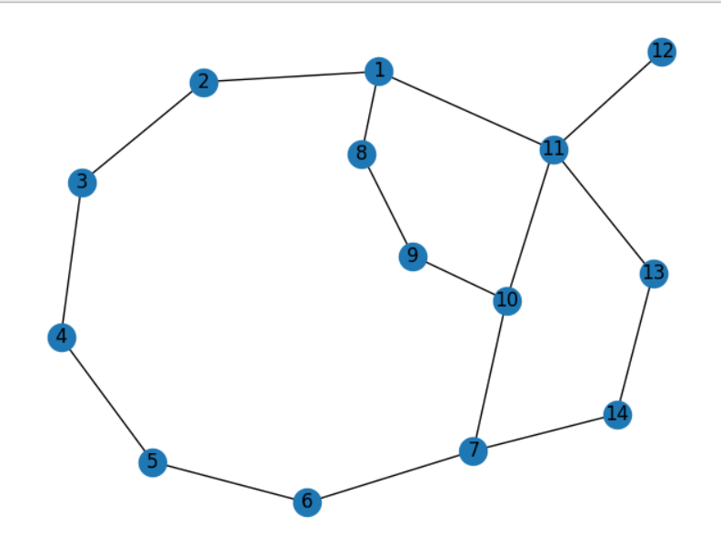
Let us take paths taken by scouts as
Path taken by Arin: 1 -> 8 -> 9 -> 10 -> 7
Path taken by Bran: 12 -> 11 -> 13 -> 14 -> 7
The towns visited are: 1, 8, 9, 10, 11, 12, 13, 14 (8 towns in total). Hence 8 is the output.
Example 2
Input
8 9
1 2
2 3
3 4
4 9
5 9
3 6
6 5
1 8
8 6
1 2
5
Output
7
Explanation
The scouts start at towns 1 and 2, with the outpost at town 5.
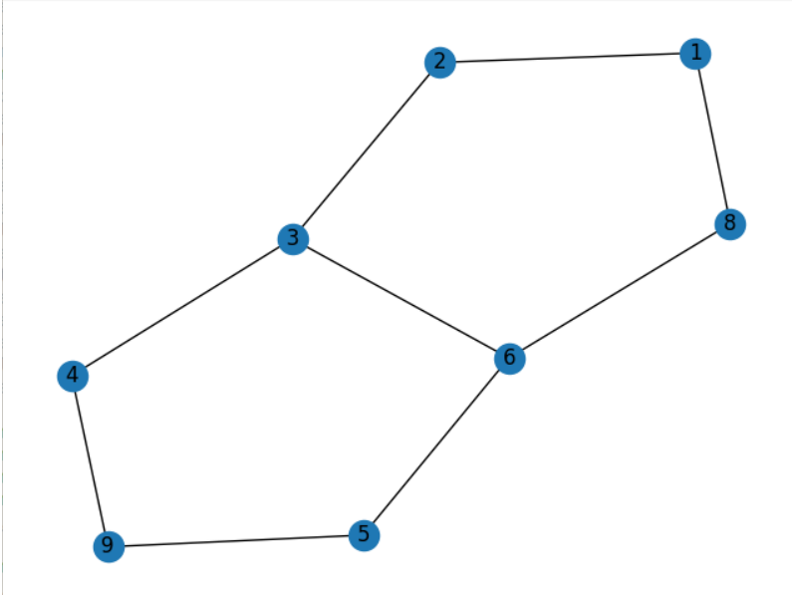
Let us take paths taken by scouts as
Arin's path: 1 -> 8 -> 6 -> 5
Bran's path: 2 -> 3 -> 4 -> 9 -> 5
The total number of unique towns visited is 7.

Question B
Nidhi's Construction
Problem Description
Nidhi enjoys arranging unit cubes so that each cube is placed next to another, forming interesting geometric patterns. The goal is to create a structured configuration from these cubes.
Nidhi starts with a set of unit cubes; each assigned a unique number. She builds a structure by placing each new cube adjacent to an existing one, following a series of commands. Each command specifies:
- The number of the existing cube,
- The number of the new cube,
- The direction in which the new cube is placed (relative to the existing cube)
You are given a cube number and your task is to process these commands and, for a given cube, output the numbers of the cubes on its four sides: Up, Down, Left, and Right (in that order).
Important Notes:
- Cube numbers range from 1 to M, where M is the total number of cubes (not provided in the input).
- Before processing the commands, order them in ascending order of existing cube number followed by new cube number (if exisiting cube numbers are equal).
- If a new cube is placed where another already exists, the new cube replaces the old one.
- The structure remains fully connected at all times.
Constraints
1 <= number of cubes <= 50
Input
The first line contains an integer N, the number of commands.
The next N lines each contain a command in the format:
<existing_cube> <new_cube> <direction>
The final line contains the number of the cube for which you need to print the four side values.
Output
Print the numbers of the cubes on the four sides (Up, Down, Left, Right) of the specified cube, separated by spaces. If there is no cube on a particular side, print -1 for that side.
Time Limit (secs)
1
Examples
Example 1
Input
8
5 6 right
1 8 top
5 7 left
1 3 left
1 2 right
1 4 down
4 5 down
5 9 down
9
Output
5 -1 -1 -1
Explanation
The given structure Nidhi constructed with cubes is shown below.
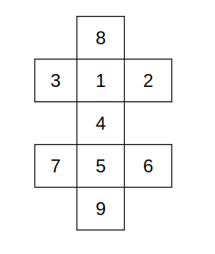
As we can see that for the cube with number 9, the top is 5, down, left and right are empty, hence the output is 5 -1 -1 -1.
Example 2
Input
6
4 5 right
1 2 left
3 4 right
1 3 down
1 6 top
4 7 top
1
Output
6 3 2 7
Explanation
The given structure Nidhi constructed with cubes is shown below.
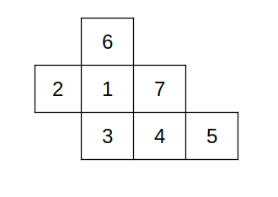
As we can see that for the cube with number 1, the top, down, left and right are 6, 3, 2, 7 respectively. Hence the output is 6 3 2 7.

Question C
Stylus Simulator
Problem Description
Raju, an avid digital artist, uses his tablet and stylus to create geometric art on a 2D canvas grid of size N × M. He carefully plans his drawing commands in advance and executes them sequentially, striving for perfection.
You are tasked with simulating Raju's drawing commands on a digital canvas. Each rectangle drawn is axis-aligned and defined by its top-left coordinates, width, and height.
Commands must be executed in the order provided. Invalid commands should be skipped but logged to the output. The following rules apply:
- Rectangles must remain fully within the grid.
- Rectangles must not touch or overlap each other, including at edges or corners.
- A rectangle completely enclosed within another is considered overlapping and is invalid.
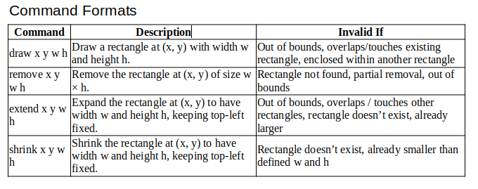
Constraints
1<= M, N <= 20
1 <= C <= 20
1 <= w, h <= 20
The grid spans from (0,0) to (N, M).
For extend or shrink commands, if the rectangle sides are equal to those defined in the command, it is a valid command.
Input
The first line contains two integers, M and N, representing the height and width of the canvas grid, respectively.
The second line contains an integer C, denoting the number of commands to be executed.
Each of the following C lines describes a command in one of the formats above.
Output
Print each invalid command exactly as it appears in the input, in order.
After processing all commands, print the total number of valid rectangles remaining on the canvas.
Time Limit (secs)
1
Examples
Example 1
Input
8 6
7
draw 0 6 3 3
draw 4 3 2 2
shrink 0 6 2 2
remove 4 3 2 2
extend 0 6 7 7
shrink 0 6 4 4
shrink 0 6 1 1
Output
extend 0 6 7 7
shrink 0 6 4 4
1
Explanation
- The canvas is 6 × 8.
- The first rectangle is drawn at (0, 6) with size 3 × 3.
- The second rectangle is drawn at (4, 3) with size 2 × 2.
- The first rectangle shrunk to 2 × 2.
- The second rectangle is removed.
- The extend command is invalid (out of bounds).
- The shrink command is invalid (already smaller).
- The final shrink reduces the rectangle to 1 × 1.
- Only one rectangle remains.
Example 2
Input
4 4
5
draw 0 2 1 2
draw 2 4 2 2
shrink 0 2 1 1
extend 0 2 1 2
draw 2 2 1 1
Output
draw 2 2 1 1
2
Explanation
- The canvas is 4 × 4.
- The first rectangle is drawn at (0, 2) with size 1 × 2.
- The second rectangle is drawn at (2, 4) with size 2 × 2.
- The first rectangle shrunk to 1 × 1.
- The rectangle is extended back to 1 × 2.
- The third draw command will overlap existing rectangle, hence invalid.
- Two rectangles remain.

Question D
Treasure Hunt
Problem Description
Explorers have found a treasure grid high in the mountains. This grid is made up of stacked cells - some contain sparkling treasures, while others are blocked by heavy rocks. The rocks can be used for climbing above, but you cannot stand in the cell where rock is present.
You begin your journey from a specific cell in the grid, aiming to collect as much treasure as possible. However, there are special rules you must follow:
- Gravity: You can only stand on a treasure cell if it is stable. A cell is stable if there is a rock directly beneath it. If you step onto an unstable treasure, you will slide down until you reach a stable cell or the bottom of the grid.
- Obstacles: Rocks (#) are obstacles. You cannot stand on them, but you can use them to climb upward into an available cell.
- Moves: You may move left or right to adjacent treasure cells, or climb upward, following the rules. Each move, slide, or climb counts toward your maximum step limit, K. Climbing onto rocks does not count as a move.
The treasures you may find are:
- + -> Diamond
- $ -> Pearl
- % -> Gold
- * -> Platinum
- # -> Rock (obstacle)
Each treasure has a value, which will be given in the input.
Goal:
Start from the source cell and reach a stable treasure cell within at most K steps. The last row is always stable (no gravity applies), but you cannot end your journey on a cell in the last row.
Constraints
1 <= N, M <= 20
1 <= K <= 20
The index of top left cell is (0,0) and the bottom right cell is (N-1, M-1).
The starting cell is always stable.
Input
The first line contains two integers: N (number of rows) and M (number of columns).
The next N lines describe the grid.
The following line contains two integers: the x and y coordinates of the starting cell.
The next line lists the values for pearl, platinum, gold, and diamond (in that order).
The last line contains the integer K (maximum allowed steps).
Output
Print a single integer: the maximum value of treasures you can collect within K moves, ending on a stable cell.
Time Limit (secs)
1
Examples
Example 1
Input
5 5
* $ * % *
# * # # +
* % $ * %
# * # # +
* $ * % *
0 0
1 2 3 4
9
Output
21
Explanation
We start at the top-left cell (0,0) on Platinum, collecting 2 points. Moving right to (0,1) adds a Pearl worth 1 point, but since it is unstable, the path slides down through the column, picking up Platinum at (1,1) for 2 points, Gold at (2,1) for 3 points, and another Platinum at (3,1) for 2 points, finally stopping at (4,1) on Pearl for 1 point. From there, the path continues right to (4,2) for Platinum worth 2 points and further right to (4,3) for Gold worth 3 points. Climbing upward, it reaches (2,3) for Platinum worth 2 points and finally (0,3) for Gold worth 3 points. The total treasure collected along this route is 21 points. points. Adding all the treasures collected along this journey gives a maximum total of 21 points.
Example 2
Input
6 3
* % *
# + $
$ * +
% # *
+ $ #
# * %
3 2
5 9 4 1
5
Output
9
Explanation
From the given cell, no moves to neighbouring stable cells are possible. The only treasure collected is the platinum at the starting location, worth 9 points.

Question E
Mis Cube
Problem Description
Noir Parker is a passionate speedcuber who spends much of his time practicing with his Rubik's Cube. His younger sister, Peni Parker, enjoys playing pranks on him. Sometimes, she shuffles his cube or comes up with more mischievous plans.
Peni's cunning scheme involves twisting one of the cube's corners and shuffling it. The image below shows this scheme.
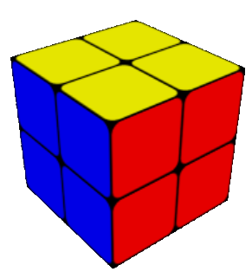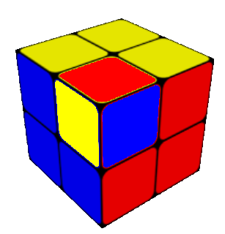
In the above example, Peni rotated the positions of the yellow-red-blue corner of the cube. This tactic makes the cube unsolvable, increasing the challenge for her brother, Noir Parker. As Noir spends time attempting to solve the cube, he senses a shift or alteration that renders it unsolvable. This realization prompts him to recognize that something has changed in the cube, contributing to the puzzle's complexity.
The cube will have six faces Top, Front, Down, Back, Left(L) and Right(R). Each face will consist of a 2x2 square piece, with each square coloured and denoted by indices as illustrated below.
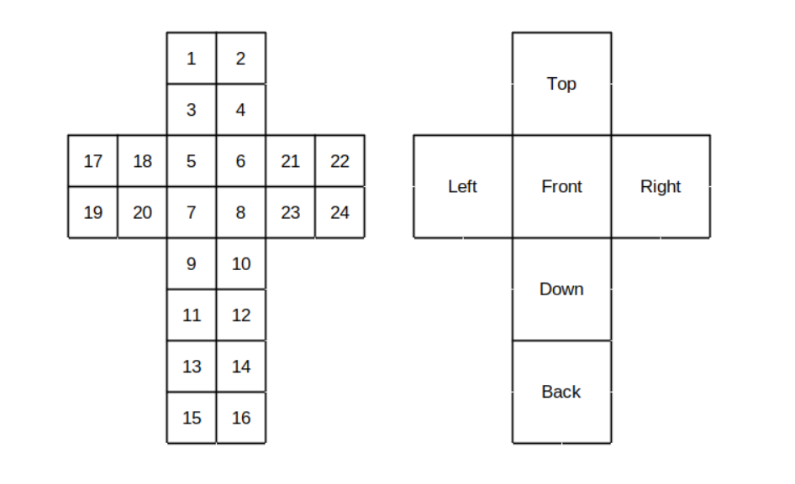
The cube faces comprise six colours, each uniquely represented by small-case alphabetical letters.
A typical cube features six fixed colours, with each face displaying a consistent colour throughout. For example, yellow colour will be opposite to white colour face. But here, cube face colour will not be constant. The colour also varies from the standard one.
Noir recognizes that his usual solving algorithm falls short, and he is reluctant to approach Peni again to inquire about the corner twist. Given the cube, can you help Noir, in finding the twisted corner!?
Note: A twisted corner on a Rubik's Cube is when a single corner piece is rotated on its own
Constraints
a <= Character used to represent colour <= z
0 < moves required to solve the cubes < 5
Input
A Single line containing the twenty-four characters space separated representing the colour present in the index in the cube.
Output
Print the letters representing the colours of the twisted corner in alphabetical order.
Time Limit (secs)
1
Examples
Example 1
Input
y y r y b r r r w w w w o o o o b y b b g g g g
Output
bry
Explanation
It is the same cube depicted in Problem Description section. The image indicates that the blue-red-yellow corner is twisted. So, the output is bry.
Example 2
Input
b y y y r g r r g g w w o o w b r b b w o o y g
Output
bry
Explanation
The image below depicts the cube.
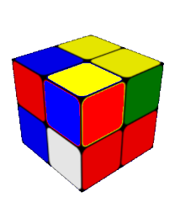
This corner is twisted similarly to example 1, but it has been shuffled with two additional moves.

Question F
ReduceExp
Problem Description
Dr. Ada adjusted her glasses, focusing intently on the equations scrawled across the whiteboard. Her team was working on an artificial neural network, where each neuron evaluated a specific mathematical expression. They noticed that the network's performance was slow, and the culprit was the time it took to evaluate these expressions.
The computation time directly depended on the number of mathematical operations involved — primarily multiplication and addition.
Example: Consider the equation x × (1 + 2) + 1 + 3 × 1. This expression requires 5 operations to evaluate fully. However, by simplifying it to 3x + 4, the team reduced the required operations to just 2. Replacing complex equations with their simplified counterparts could significantly enhance the network's speed.
Further exploration revealed that certain quadratic equations could be factored without changing their results, further reducing the number of operations needed for evaluation. Ada's team identified three common forms amenable to this simplification:
- Form 1: a1a2xx + a1b2x + a2b1x + b1b2 can be simplified to (a1x + b1) (a2x + b2).
- Form 2: a1a2xy + a1b2x + a2b1y + b1b2 can be simplified to (a1x + b1) (a2y + b2).
- Form 3: a1a2xx + a1b2x + a2b1xy + b1b2y can be simplified to (a1x + b1y) (a2x + b2).
Here, x and y represent variables, while a1, a2, b1, and b2 are constants. The key is matching the variable structure, not necessarily the exact equation coefficients. For instance, a1a2yy + a1b2y + a2b1y + b1b2 or a1a2yy + (a1b2+a2b1) y + b1b2 still fits Form 1.
The equation will contain only the variables x and y. The expression will never contain cubic terms, and it only have square terms (i.e., have x*x, x*y and not x*x*x, x*x*y etc.). Follow precedence with order of brackets, multiplication and then addition.
The Challenge: You are tasked with optimizing a given quadratic equation to minimize the number of operations required for evaluation. You can only apply multiplication, addition, and one of the three factoring forms mentioned above.
Good luck!
Note: You can apply only one form to the given equation to reduce it.
Constraints
Coefficients of the variables < 100
Input
A single-line equation involving the elements x,y,*,+,(,), and integers.
Output
Single integer representing minimum operations required after optimizing the equation.
Time Limit (secs)
1
Examples
Example 1
Input
x*(x+2+1)+1+1
Output
3
Explanation
We can do the usual reduction of multiplication and addition which will result in - xx+3x+2 and the number of operations required is 4.
After careful observation we can say that the equation is in first given form to factorize.
Applying it will give us - (x+1)*(x+2)
Above optimized equation requires only 3 operation which is the minimum possible. Hence print 3.
Example 2
Input
2*x*y+4*x+y+2+y*y
Output
6
Explanation
The given input equation requires 8 operations.
Now there is no further reduction by addiction and subtraction.
Factorizing it (2*x+1)*(y+2)+y*y now it requires 6 operation, which is the minimum. Hence print 6.
Example 3
Input
10*5+6*3
Output
0
Explanation
As we can see that the equation consists of only integers, and it can be evaluated fully to get the result 68.
Thus, the reduced one (68) have no operations to perform, hence print 0.

